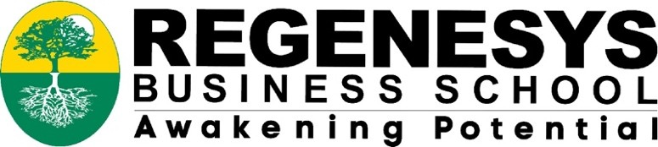
02 April 2024,

Dear Happiness Thulubheke Zwane,

Approval of Ethical Clearance
Project title: Evaluating perceptions and implications of teenage pregnancies in a rural school within uMkhanyakude District, KwaZulu-Natal, South Africa.

This letter serves to notify you that your application for ethical clearance to conduct the above research towards your MPM dissertation has been fully approved by the Regenesys Business School (RBS) Ethics Committee.

Please note that any changes to the title and research protocols (title/method/data collection/sample etc.) must be reviewed and amendments approved prior to commencement of the data collection.

All research being conducted during the Covid-19 pandemic must strictly follow the RBS research guidelines and protocols, as well as that of the South African National Research Ethics Council.
Please note that this is valid for a period of one year from the date of issue. Furthermore, a copy of this approval letter must be appended to your dissertation /research report.

We wish you every success in your research.
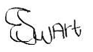
Yours Sincerely
Dr Emetia Swart
Head of Research and Innovation
Tel: +27 (0) 11 669 5000
Fax: +27 (0) 11 669 5001

